**What is AIGPUSniffer? | mac | illustrator**

These are the few questions which cross to one’s mind while we talk about **AIGPUSniffer**:

What’s **aigpusniffer mac**? What’s **aigpusniffer illustrator**? So, let’s start clarifying them one by one.

Occasionally it happens that your **Mac** may exhibit files or some names that one can’t keep up with normally with their shown name. **Aigpusniffer mac** is one such common paradigm that shows up frequently because of certain issues. It works behind the **Adobe Illustrator** in the background but because of unresolved issues it keeps on popping even if we don’t use **Adobe Illustrator** or **Adobe** **In Design**. So, you might be curious like how to resolve this issue. So, let’s get up to that.

**What is AIGPUSniffer**?

In order to make a software work evenly on any **operating system** like ***Mac OS Mojave***, Windows, etc, we’ve several utilities and processes which runs along with them in the background but we don’t always know about their role and working. **AIGPUSniffer** is one such utility which runs in the background for adobe applications to work smoothly. It’s an additional utility in several **Adobe applications** like **Adobe photoshop**, **Adobe Illustrator**, **Adobe In Design**, etc. It inspects your GPUs (Graphical processing units) potency if it’s capable enough to let the app work in your system, i.e., it checks for the compatibility of the app you’re trying to open in you system. It continues working in the background with the adobe applications but it may pop up on your screen sometimes because of some issues but those issues come by default in the utility. So, there’s nothing to worry about that.

**AIGPUSniffer** working

It’s there along with other adobe applications in order to check its compatibility with your OS, and thus prevents the abrupt crashing of the adobe applications and acquires misaddressed driver calls. Many users delete it because they don’t know about it’s working and they think it’s of no use but it’s recommended to keep it otherwise adobe applications may crash suddenly while working. It helps in running the other adobe apps smoothly. **It’s completely safe and legalized and there’s no need to close or delete AIGPUSniffer.exe. It works to check if everything (Adobe application which we opened) is working smooth and sound and whether it’s compatible with our system or not.**

Application Details

|  |  |
| --- | --- |
| Name | AIGPUSniffer.exe |
| Owner | Adobe Systems Incorporated |
| Type | Executive File |
| Function | Stops GPU crashes when starting Adobe applications |
| Safe | 100% safe and legal |
| Issues | Unexpectedly quits and appears on Mac dock |

Common issues related to **AIGPUSniffer**

1. **AIGPUSniffer might quit unexpectedly –** It usually happens on Mac OS Mojave and reasons are either imperfection in Adobe application updates (outdated Adobe software, wrong file type, etc.,) or unusual GPU acceleration. It leads the application to crash and stop working. Solutions for this are:
2. *Disabling GPU acceleration on Adobe Application*: Turn off the GPU acceleration on the application it’s appearing. Follow the steps mentioned below to disable GPU acceleration:

Step 1- Move to Program’s preferences. Click on illustrator if you’re using Adobe Illustrator and then click on preferences.

Step 2 - Now click on GPU Performance tab which is present on the left side menu.

Step 3 – And then deselect the GPU Performance option and then click on OK.

Done with the process.

1. Changing File type Association settings in Adobe Bridge preferences: Follow the steps mentioned below to change file type:

Step 1: Open *Adobe Bridge > edit > preferences* if you’re using window.

Step 2: Click on ‘*File Type Association*’ which is present on the left side.

Step 3: Configure the settings i.e., associate the file with the application in which you’re facing problems. For example: If you’re facing issues with Illustrator, then after scrolling down to it, set it to *Adobe Illustrator CC* from default.

Done with the process.

1. **AIGPUSniffer appearing on Mac dock and can’t be closed –** If you’re thinking why AIGPUSniffer doesn’t close on Mac, because it’s designed to recently used apps. Follow the below mentioned steps to remove AIGNUSniffer from dock:
2. Open System Preferences > Dock on Mac.
3. Then deselect ‘Show recent applications in Dock’ option.

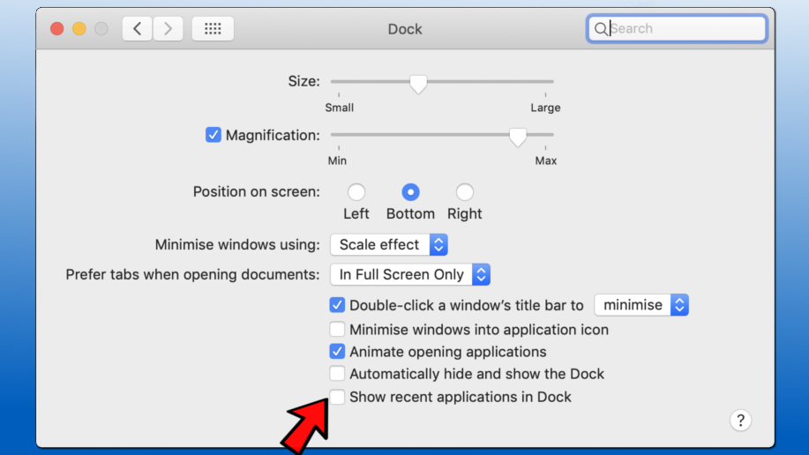

1. Close System Preferences.

Done with the process.

**3. AIGPUSniffer won’t stop**: Some users report that AIGPUSniffer doesn’t quits on its own even after closing the adobe applications like Adobe Illustrator which results in very high CPU use leading your computer to slow down its process. Since, it has not been fixed yet from Adobe side so you need to fix manually using Task Manager.

1. press CTRL+ALT+DEL and select to open *Windows Task Manager*.

2. Then find AIGPUSniffer, right click on it to select *End Task*. 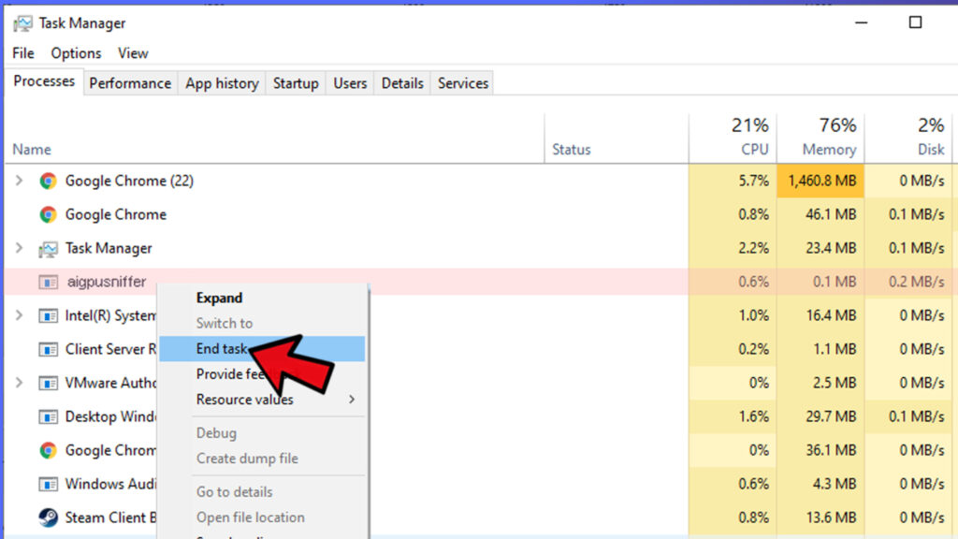 Done with quitting.

Now since you know that AIGPUSniffer is completely safe and it doesn’t pose any threat to your computer so you don’t need to remove it.